Given the roots of two binary trees root and subRoot, return true if there is a subtree of root with the same structure and node values of subRoot and false otherwise.

A subtree of a binary tree tree is a tree that consists of a node in tree and all of this node's descendants. The tree tree could also be considered as a subtree of itself.

**Example 1:**

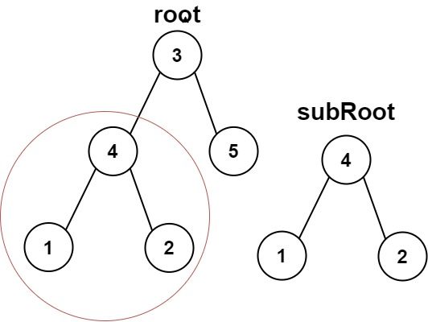

Input: root = [3,4,5,1,2], subRoot = [4,1,2]  
Output: true

**Example 2:**

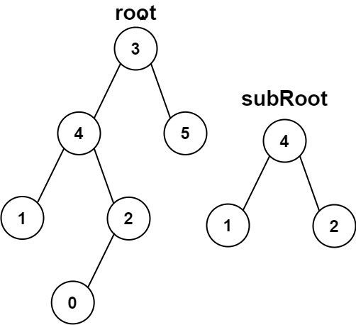

Input: root = [3,4,5,1,2,null,null,null,null,0], subRoot = [4,1,2]  
Output: false

**Constraints:**

* The number of nodes in the root tree is in the range [1, 2000].
* The number of nodes in the subRoot tree is in the range [1, 1000].
* -104 <= root.val <= 104
* -104 <= subRoot.val <= 104